Advanced Lane Finding Project
The goals / steps of this project are the following:
- Compute the camera calibration matrix and distortion coefficients given a set of chessboard images.
- Apply a distortion correction to raw images.
- Use color transforms, gradients, etc., to create a thresholded binary image.
- Apply a perspective transform to rectify binary image ("birds-eye view").
- Detect lane pixels and fit to find the lane boundary.
- Determine the curvature of the lane and vehicle position with respect to center.
- Warp the detected lane boundaries back onto the original image.
- Output visual display of the lane boundaries and numerical estimation of lane curvature and vehicle position.

Camera Calibration

1. Briefly state how you computed the camera matrix and distortion coefficients. Provide an example of a distortion corrected calibration image.
The code for this step is contained in the first code cell of the IPython notebook located in "Advanced_Lane_Detection.py" line 39-77
I start by preparing "object points", which will be the (x, y, z) coordinates of the chessboard corners in the world. Here I am assuming the chessboard is fixed on the (x, y) plane at z=0, such that the object points are the same for each calibration image. Thus, objpoints is just a replicated array of coordinates, and objpoints will be appended with a copy of it every time I successfully detect all chessboard corners in a test image. Imgponits will be appended with the (x, y) pixel position of each of the corners in the image plane with each successful chessboard detection.
I then used the output objpoints and imgponits to compute the camera calibration and distortion coefficients using the cv2.calibrateCamera() function. I applied this distortion correction to the test image using the cv2.undistort() function and obtained this result:
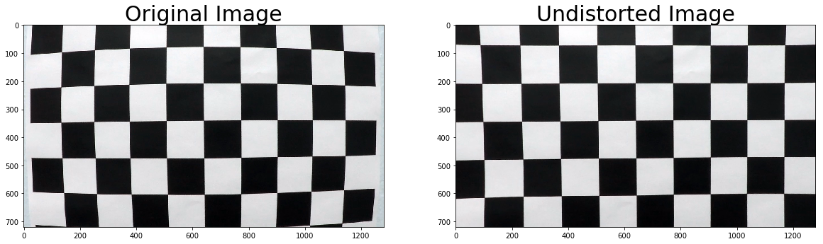

Pipeline (single images)

1. Provide an example of a distortion-corrected image.
To demonstrate this step, I will describe how I apply the distortion correction to one of the test images like this one:
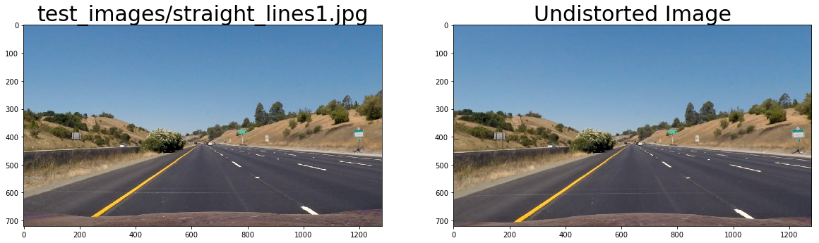

2. Describe how (and identify where in your code) you used color transforms, gradients or other methods to create a thresholded binary image. Provide an example of a binary image result.
I used a combination of color and gradient thresholds to generate a binary image (thresholding steps at lines 80-124 Advanced_Lane_Detection.py)
Here's an example of my output for this step. (note: this is not actually from one of the test images)
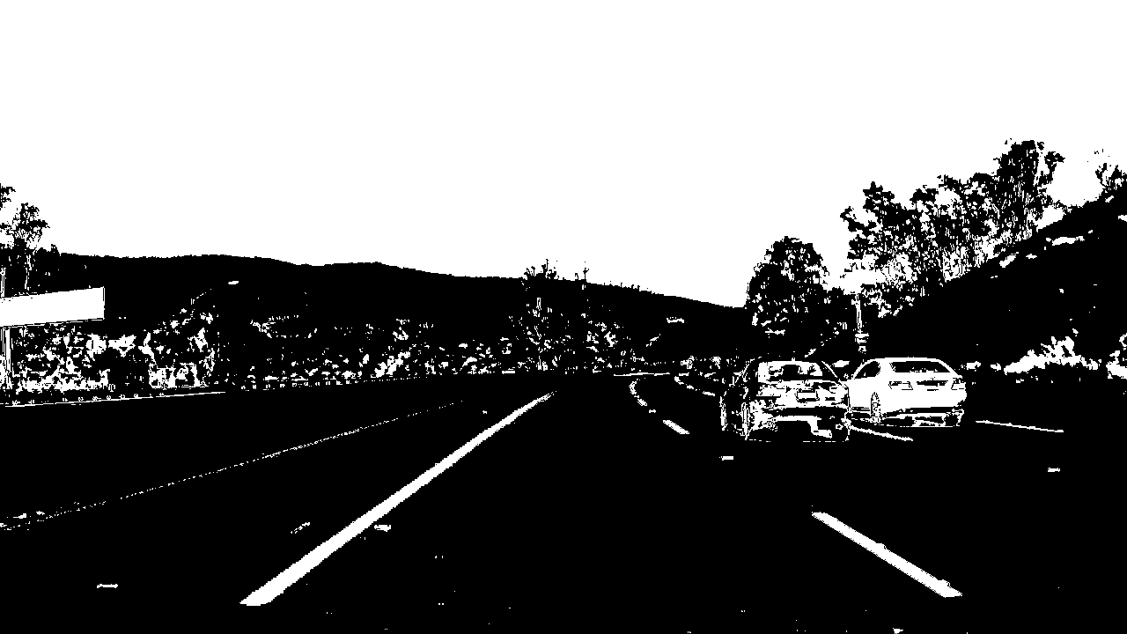

3. Describe how (and identify where in your code) you performed a perspective transform and provide an example of a transformed image.
The code for my perspective transform includes a function called warper(), which appears in lines 128 through 139 in the Advanced_Lane_Detection.py
The warp_image() function takes as inputs an image (img), as well as source (source_points) and destination (destination_points) points.Then the cv2.getPerspectiveTransform() function to generate the bird-view image.
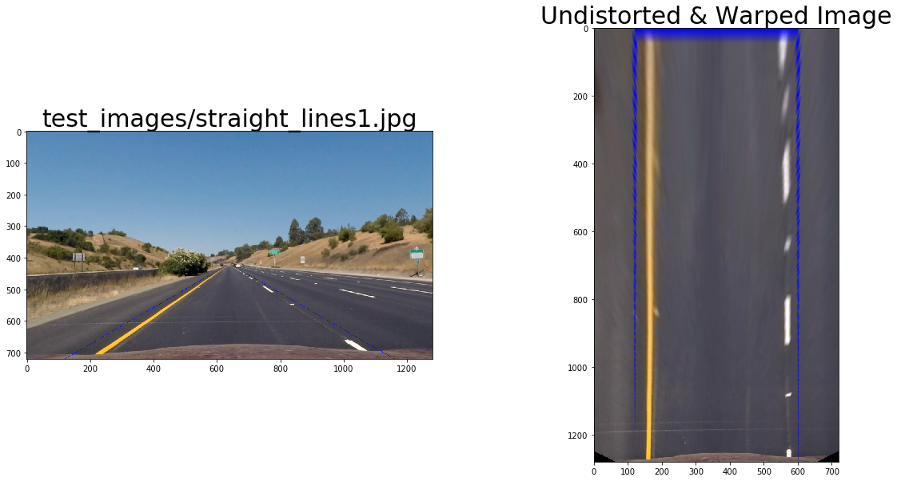

4. Describe how (and identify where in your code) you identified lane-line pixels and fit their positions with a polynomial?
Fit my lane lines with a 2nd order polynomial. Convert the pixel positions to length meter and use the function np.polyfit()
Line 440-449 in Advanced_Lane_Detection.py

5. Describe how (and identify where in your code) you calculated the radius of curvature of the lane and the position of the vehicle with respect to center.
Estimate meter per pixel by the fact that the lane is 3.7 meter and each dashed line is 3 meters long. The np.polyfit() function will get polynomial parameters.Then we can calculate the radius using the polynomial. Assume the camera is in the middle. The distance between the center of the frame-image and average of the the bottom-intercepts of left and right lanes, when converted from pixels to meters, gives us an estimate of the position of the vehicle.

I did this in lines 450-451 in Advanced_Lane_Detection.py

6. Provide an example image of your result plotted back down onto the road such that the lane area is identified clearly.
I implemented this step in lines 468-553 in Advanced_Lane_Detection.py in the function find_lane_line(). Here is an example of my result on a test image:
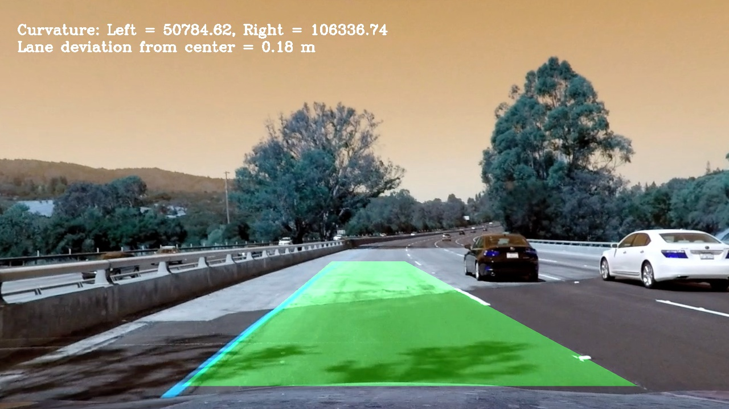

1. Provide a link to your final video output. Your pipeline should perform reasonably well on the entire project video (wobbly lines are ok but no catastrophic failures that would cause the car to drive off the road!).
See videos in the folder please

Discussion

1. Briefly discuss any problems / issues you faced in your implementation of this project. Where will your pipeline likely fail? What could you do to make it more robust?
- The output of challenge video is not good. My best guess is that the combination function should be improved.

- Color threshold and gradient threshold is fixed in this algorithm. It should be adaptive depends on various circumstance such as lighting,shadows.

